Working With Dataset

# Exploration Of Cholesterol By Age And Gender

|  |  |
| --- | --- |
| Team ID | PNT2022TMID04535 |
| Project Name | Visualizing and Predicting Heart Diseases with an Interactive Dashboard |

## Dataset Link:

<https://www.kaggle.com/datasets/rishidamarla/heart-disease-prediction>.

## About Dataset:

This is a kaggle dataset. It contains 14 fields. The goal of the dataset is to predict the presence of heart disease.

## Exploration:

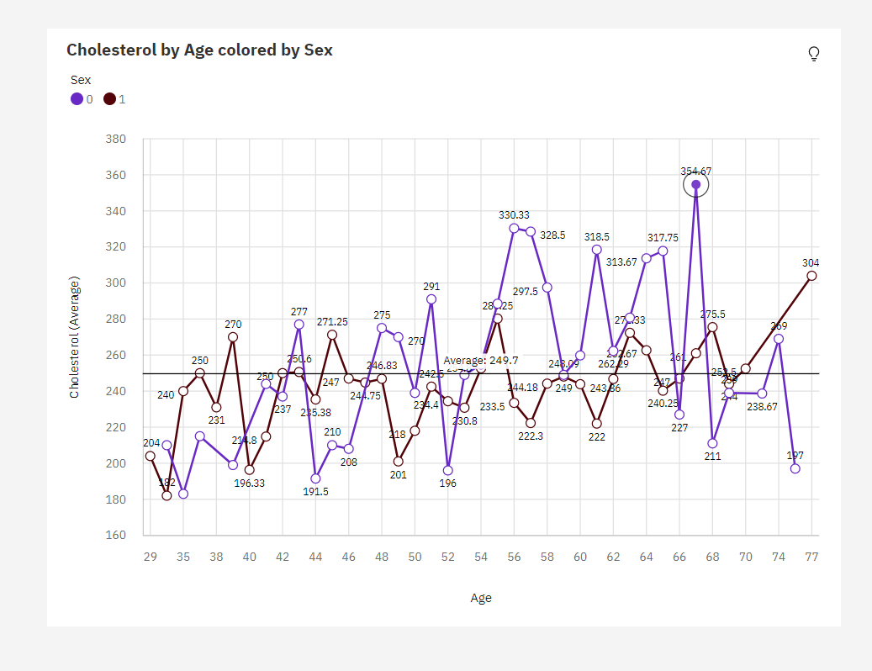

1. The most common values of **Age** are 54 (5.9 %) and 58 (5.6 %), together occurring 31 times, which is 11.5 % of the total.
2. Over all **ages** and **sexes**, the average of **Cholesterol** is 249.7.
3. The average values of **Cholesterol** range from 182 to 354.7.
4. Cholesterol is unusually high when the combination of Age and Sex is 67 and 0.